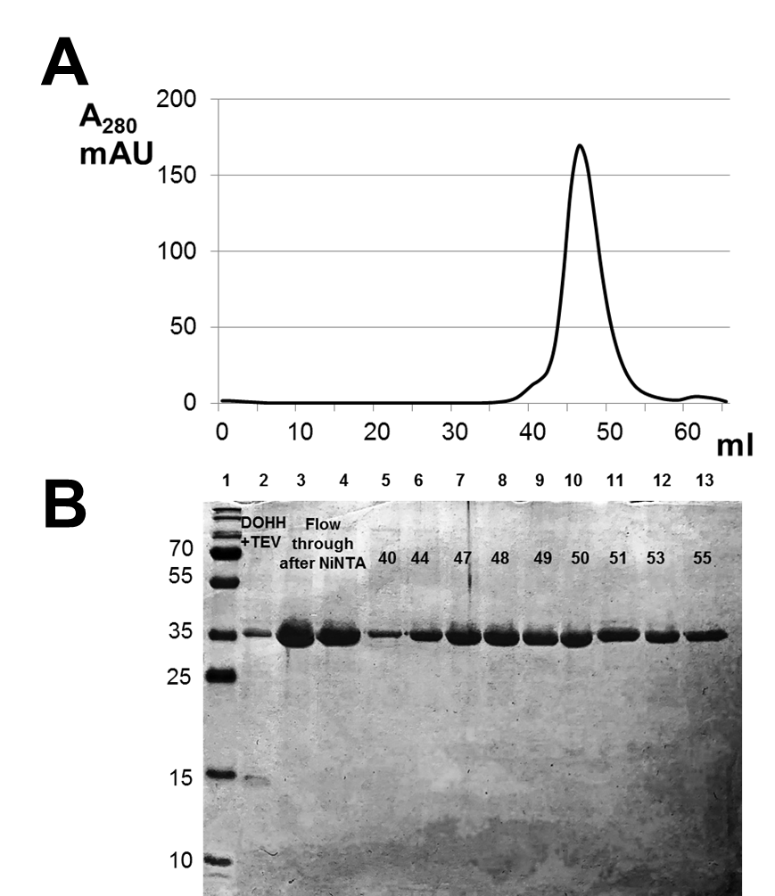
Figure S1. Purification of CaDOHH after treatment with the TEV-protease. (A) Size-exclusion chromatography elution profile of CaDOHH protein. (B) Analysis of CaDOHH protein in SDS-PAGE (fractions in ml are shown by numbers above the peaks).

