Supplementary
STRUCTURAL ANALYSIS OF THE 5′-FLANKING REGION OF HUMAN ALPHA-FETOPROTEIN ENCODING GENE
C. Zhang, H. J. Zhao, J. Wang, W. Y. Zhou, T. J. Zhang, C. B. Zhang

Table 1S. Sequences of oligonucleotides used for qRT-PCR and plasmid constructs assays.

Oligonucleotides sequences Product size(bp)
Primers for plasmid constructs
AFP | pLuc1 |  | Sense | 5’-GGGGTACCGGCAAGCTTATATAGTTTGC-3’ |  |  | 1871
 |  |  | Antisense | 5’- CGACGCGTCTATTCCATATTCATTTC-3’
 | pLuc1-1 |  | Sense | 5’-GGGGTACCctaacaaatg aatggg-3’ |  |  | 1567
 |  |  | Antisense | 5’- CGACGCGTCTATTCCATATTCATTTC-3’
 | pLuc2 |  | Sense | 5’- GGGGTACCCACCTGTGAAGCTTTAG-3’ |  |  | 1004
 |  |  | Antisense | 5’- CGACGCGTCTATTCCATATTCATTTC-3’
 | pLuc2-1 |  | Sense | 5’- GGGGTACCacatcgcata ctaaatac-3’ |  |  | 677
 |  |  | Antisense | 5’- CGACGCGTCTATTCCATATTCATTTC-3’
 | pLuc3 |  | Sense | 5’- GGGGTACCCCTGGCATATGATAGG-3’ |  |  | 448
 |  |  | Antisense | 5’- CGACGCGTCTATTCCATATTCATTTC-3’
 | pLuc3-1 |  | Sense | 5’- GGGGTACCgtttgaggagaatatttg-3’ |  |  | 287
 |  |  | Antisense | 5’- CGACGCGTCTATTCCATATTCATTTC-3’
 | pLuc4 |  | Sense | 5’- GGGGTACCCTCTGTGTCCTTGAAC-3’ |  |  | 215
 |  |  | Antisense | 5’- CGACGCGTCTATTCCATATTCATTTC-3’
GADD45α | pLuc-1 | Sense |  | 5’-GGGGTACCTTTGCAGAAATTAC-3’ |  |  | 1626
 |  | Antisense |  | 5’-CGACGCGTATTGCAAACTGCAGGTC-3’
 | pLuc-2 | Sense |  | 5’- GGGGTACCGCTTTCTGTGGAAAAGAT -3’ |  |  | 979
 |  | Antisense |  | 5’-CGACGCGTATTGCAAACTGCAGGTC-3’
 | pLuc-3 | Sense |  | 5’- GGGGTACCGTGCCGCAACTATTATAG -3’ |  |  | 646
 |  | Antisense |  | 5’-CGACGCGTATTGCAAACTGCAGGTC-3’
 | pLuc-4 | Sense |  | 5’- GGGGTACCTTTTCCGCTCCTCTCAAC -3’ |  |  | 452
 |  | Antisense |  | 5’-CGACGCGTATTGCAAACTGCAGGTC-3’
 | pLuc-5 | Sense |  | 5’-GGGGTACCAATTAGTGTCGTGCGGC-3’ |  |  | 258
 |  | Antisense |  | 5’-CGACGCGTATTGCAAACTGCAGGTC-3’
Primers for qRT-PCR
Firefly luciferase |  | Sense |  | 5’-GCTCTGCCTCATAGAACTG-3’ |  |  | 110
 |  | Antisense |  | 5’-TGATGGAATGGAACAACACT-3’
Renilla luciferase |  | Sense |  | 5’-TCGTCGTCCAACATTATCAT-3’ |  |  | 174
 |  | Antisense |  | 5’-GCACCTTCAACAATAGCATT-3’

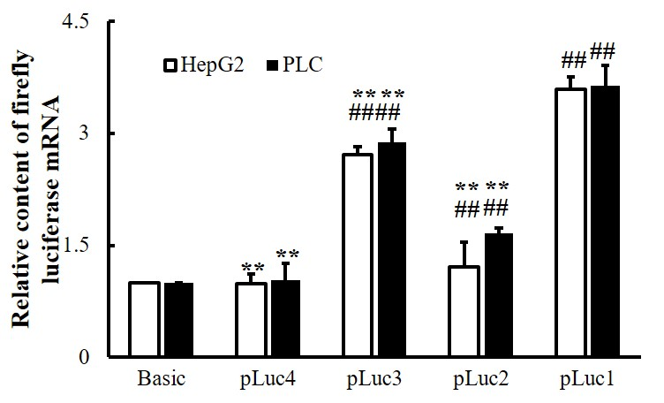
Supplementary Figure 1. PCR analysis of luciferase mRNA conferred by different 5’-truncated fragments of human AFP gene in transfected HepG2 and PLC cells. The mRNA content of Firefly Luciferase was changed after transfection of plasmids containing different lengths of regulatory sequences into HepG2 and PLC cells. Data are representative of an experiment that was repeated at least three times. ##P < 0.01 and**P < 0.01 compared with controls
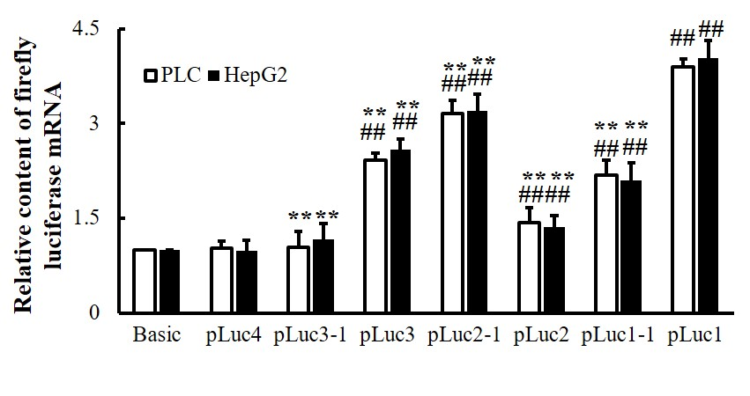
Supplementary Figure 2. PCR analysis of luciferase mRNA conferred by different 5’-truncated fragments of human AFP gene in transfected HepG2 and PLC cells. Changes in the mRNA content of Firefly Luciferase after transfection of plasmids containing different lengths of regulatory sequence into HepG2 and PLC cells. ##P < 0.01 and**P < 0.01 as compared with control. These experiments were repeated at least three times.

